Copyright reserved

Please turn over

**NATIONAL CERTIFICATE**

**STRENGTH OF MATERIALS AND STRUCTURES N5**

**23**

**April 2021**

**This marking guideline consists of 5 pages.**



**MARKING GUIDELINE**

-2-

# QUESTION 1

✓

1.1 𝜎𝜎𝑚𝑚𝑚𝑚𝑚𝑚 = 𝐴𝐴𝑙𝑙𝑙𝑙𝐹𝐹𝑚𝑚𝑙𝑙𝑙𝑙 = 𝜋𝜋4.(0,04702− 000 0,0222) =✓79 ,863 𝑀𝑀𝑀𝑀𝑚𝑚 ✓ ✓ (4)

𝐹𝐹 70 000✓ ✓

1.2 𝜎𝜎𝑚𝑚𝑚𝑚𝑚𝑚 = 𝐴𝐴𝑚𝑚𝑚𝑚𝑚𝑚 = 𝜋𝜋.(0,042) =✓ 55,704 𝑀𝑀𝑀𝑀𝑚𝑚 (3)

4

|  |  |
| --- | --- |
| 𝐻𝐻 𝐸𝐸 190 × 109 |  |
| ✓  6  𝜀𝜀𝑆𝑆 = 𝜎𝜎𝐸𝐸𝑆𝑆 = 55190,704 × × 10109 = 2,932 × 10−4 ✓  ✓  𝜀𝜀 = 𝜀𝜀 + 𝜀𝜀 = 4,203 × 10−4 + 2,932 × 10−4 = 7,135 × 10−4 ✓✓ | (7) |

1.3 𝜀𝜀 = 𝜎𝜎𝐻𝐻 = 79,863 × 106 ✓= 4,203 × 10−4 ✓

𝑇𝑇 𝐻𝐻 𝑆𝑆

✓

1.4 𝑋𝑋 = 𝜀𝜀𝐻𝐻 = 4,203 × 10−4 = 9✓ ,552 × 10−3 ✓✓ (4)

𝐻𝐻 𝐿𝐿 (0,124−0,08)

1.5 1 1✓ −3✓ ✓✓

𝑈𝑈𝐻𝐻 = 2 .𝐹𝐹. 𝑋𝑋𝐻𝐻 = 2. (70 000). 9,552 × 10 = 334,32 𝐽𝐽 (4)

**[22]**

# QUESTION 2

2.1 𝐴𝐴𝑆𝑆 = 𝜋𝜋4 . 0,0152. 3 = 5,301 × 10−4 𝑚𝑚2

𝐴𝐴𝑇𝑇 = 𝜋𝜋4 . 0,152 = 17,671 × 10−3 𝑚𝑚2

𝐴𝐴𝐶𝐶 = 𝐴𝐴𝑇𝑇 − 𝐴𝐴𝑆𝑆 = 17,141 × 10−3 𝑚𝑚2 ✓

𝐹𝐹𝑇𝑇 = 𝐹𝐹𝐶𝐶 + 𝐹𝐹𝑆𝑆 = 300 000 𝑁𝑁 ✓

𝑋𝑋𝐶𝐶 = 𝑋𝑋𝑆𝑆

𝐴𝐴𝐹𝐹𝑐𝑐𝑐𝑐..𝐸𝐸𝐿𝐿𝐶𝐶𝐶𝐶 =𝐹𝐹𝑆𝑆.𝐸𝐸𝐿𝐿𝑆𝑆 ✓ 𝐴𝐴𝑆𝑆. 𝑆𝑆

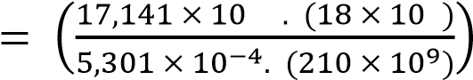 −4 9

∴ 𝐹𝐹𝐶𝐶. 𝐹𝐹𝑆𝑆 ✓

∴ 𝐹𝐹𝐶𝐶 = 0,277. 𝐹𝐹𝑆𝑆 ✓

𝐹𝐹𝑇𝑇 = 0,277.𝐹𝐹𝑆𝑆 + 𝐹𝐹𝑆𝑆 = 300 000 𝑁𝑁 ✓

∴ 𝐹𝐹𝑆𝑆 = 234 896,058 𝑁𝑁 ✓

∴ 𝐹𝐹𝐶𝐶 = 300 000 − 234 896,058 = 65 103,943 𝑁𝑁 ✓

65 103,943✓ ✓

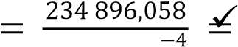 ∴ 𝜎𝜎𝐶𝐶 = 17,141 ×10− 3 = 3,798 ✓ 𝑀𝑀𝑀𝑀𝑚𝑚

∴ 𝜎𝜎𝑆𝑆 443,117 𝑀𝑀𝑀𝑀𝑚𝑚 ✓

5,301 ×10 ✓

(14)

-3-

2.2 𝑋𝑋𝐶𝐶 = 𝑋𝑋𝑆𝑆

𝜎𝜎 𝑐𝑐𝐸𝐸.𝐿𝐿𝐶𝐶𝐶𝐶 = 𝜎𝜎𝑆𝑆𝐸𝐸.𝑆𝑆𝐿𝐿𝑆𝑆 ✓ ✓

9 6

∴ 𝜎𝜎𝑆𝑆 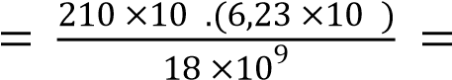72,683 𝑀𝑀𝑀𝑀𝑚𝑚 ✓

𝐹𝐹𝐶𝐶 + 𝐹𝐹𝑆𝑆 = 800 000 ✓

𝜎𝜎𝐶𝐶.𝐴𝐴𝐶𝐶 + 𝜎𝜎6𝑆𝑆. (0,0176. 𝐴𝐴𝑆𝑆 = 800 000−𝐴𝐴𝑆𝑆)✓ + 72,683 ×106. 𝐴𝐴✓ 𝑆𝑆 = 800 000

6,23 × 10

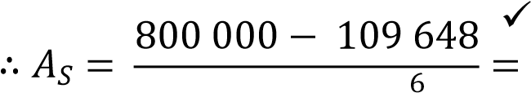10,389 × 10−3 𝑚𝑚2 ✓

66,453 × 10 (8)

2.3 𝑚𝑚 = 𝐸𝐸𝑆𝑆 = 210✓=11,667 ≈ 12 ✓

𝐸𝐸𝐶𝐶 18 ✓

(Steel is 12 x stronger than concrete) (3)

**[25]**

# QUESTION 3

✓ ✓

𝑝𝑝

𝑙𝑙 = 2.𝜎𝜎𝑖𝑖.𝐷𝐷.𝜂𝜂 = 2.(1204 × ×10106 6.( 3).,(20),75 ) = 0✓ ,071 𝑚𝑚 = 71,111 𝑚𝑚𝑚𝑚 ✓ (4)

𝑡𝑡

**[4]**

# QUESTION 4

4.1 ✓

99 kN

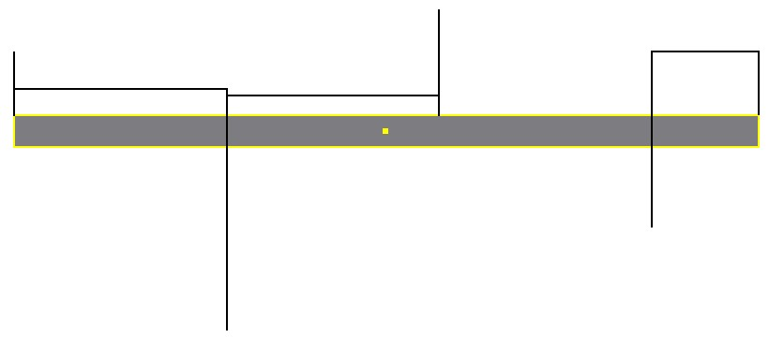

kN/m

25

kN/m

19

kN

105

202

kN

kN/m

60

60

kN

✓

✓

✓

✓

*√*

✓

*√*

# FIGURE 1 (8)

✓

4.2 𝐵𝐵𝑀𝑀𝐵𝐵 = 60. (2) + 25. (2). 22 = 170 𝑘𝑘𝑁𝑁/𝑚𝑚 ✓

2 ✓ 2 ✓ ✓

𝐵𝐵𝑀𝑀𝐶𝐶 = 60. (4) + 25.(2). 2 + 2− 202.(2) + 19. (2). 2 = 24 𝑘𝑘𝑁𝑁/𝑚𝑚

(5)

**[13]**

-4-

# QUESTION 5

1 3 −9

𝐼𝐼𝑋𝑋1 = 12 . (0,1). 0,006 = 18 × 10

𝐼𝐼𝑋𝑋2 = 15,13 × 10−6✓ ✓✓

𝐼𝐼𝑋𝑋𝑇𝑇 = 2.18 × 10−9 + 15,13 × 10−6 = 15,134 × 10−6

𝐼𝐼𝑋𝑋1 = 121 . (0,006). 0,13 = 0,5 × 10−6

𝐼𝐼𝑌𝑌2 = 1,385 × 10−−66✓ −6 ✓ −6 ✓

𝐼𝐼𝑌𝑌𝑇𝑇 = 2.0,5 × 10 + 1,385 × 10 = 2,385 × 10

∴ 𝐼𝐼𝑙𝑙𝑙𝑙𝑚𝑚𝑙𝑙𝑙𝑙 = 2,385 × 10−6✓

𝐴𝐴𝑇𝑇 = 2. (0,1 × 0,006) + 2,73 × 10−3 = 3,93 × 10−3

✓

𝐿𝐿𝐸𝐸 = 12 × 0,5 = 6 𝑚𝑚✓

2,385 × 10−6 ✓

𝑘𝑘 = 3,93 × 10−3 ✓= 0,025 ✓

6 ✓ ✓

|  |  |
| --- | --- |
| 0,025✓ | ✓ |

𝑆𝑆𝑆𝑆 = = 243,559

𝑀𝑀𝑆𝑆 = 1+𝑚𝑚𝜎𝜎.(.𝐴𝐴𝑆𝑆𝑆𝑆2) = 125 ×1+10𝑚𝑚.(26 .(3,93 ×1043,5592) −3✓)= 110 000 𝑁𝑁✓✓

∴ 𝑚𝑚 = 5,843 × 10−5✓ **[19]**

# QUESTION 6

Consider the shear stress limit:

3.𝜏𝜏 𝜋𝜋 .0,0633 .(55 ×106) ✓

𝜋𝜋.𝐷𝐷

𝑇𝑇 = = = 2700,314 𝑁𝑁𝑚𝑚 ✓

16 16 ✓

Consider the angle of twist limit: ✓

𝜋𝜋.𝐷𝐷4.𝐺𝐺 .𝜃𝜃 𝜋𝜋 .0,0634 .70 ×109 .571,3 ✓ ✓ 𝑇𝑇 = 32.𝐿𝐿 = 32 .(0,6)✓= 3 148,867 𝑁𝑁𝑚𝑚

Maximum torque:

𝑇𝑇 = 2 700,314 𝑁𝑁𝑚𝑚 (𝑙𝑙𝑚𝑚𝑚𝑚𝑙𝑙𝑙𝑙𝑙𝑙𝑠𝑠 𝑣𝑣𝑚𝑚𝑙𝑙𝑣𝑣𝑙𝑙) ✓

The smaller torque value will ensure that both shear stress and angle of twist are within

the given limits. ✓ ✓ **[10]**

-5-

# QUESTION 7

7.1 • Protective coating;

* Cathodic protection (Any other relevant answer) (2)

7.2 • Electroplating

* Galvanising
* Anodising
* Chroming
* Metal spray (Any other relevant answer) (5)
* **[7]**

# TOTAL: 100